08/15/2025, Legacy (last week) Worship

<https://www.youtube.com/live/JIH8CL6Zbg0?si=ADVseIQl9nHbKCom>

“It’s Never Too Late to Turn Back / Foreign Faith,” Phil EuBank, Lead Pastor

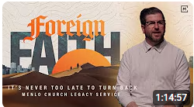

Introduction: 9:32/1:14:57

Mark Swarner, Campus Pastor

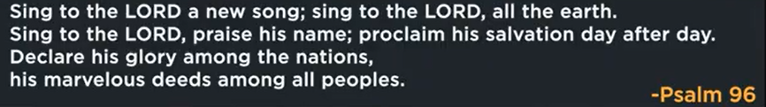

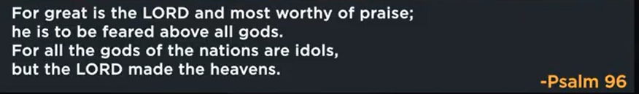

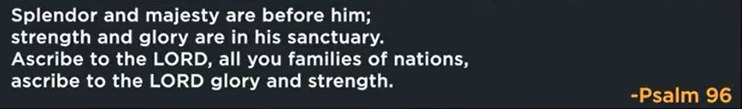

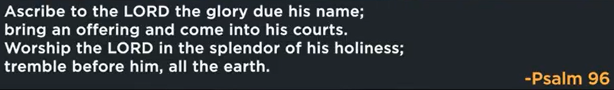

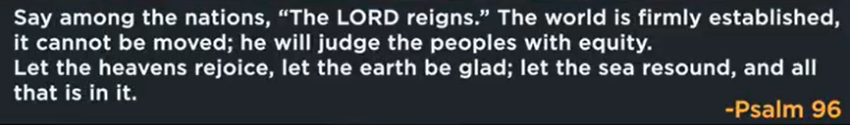

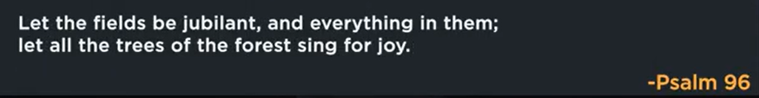

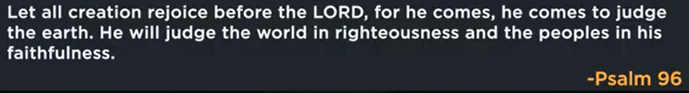

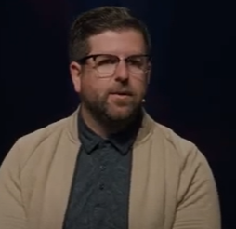

Phil EuBank, Lead Pastor

15:41/1:14:56

We want to define our future.



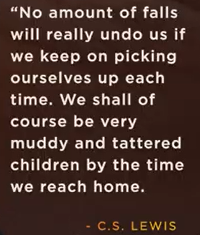

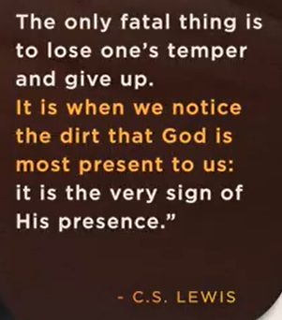

No amount of falls will ready undo us if we keep o picking ourselves up each time. We shall of course be very muddy and tattered children by the time we reach home. The only fatal thing is to lose one’s temper and give up. It is when we notice the dirt that God is most present to us: It is the very sign of his presence.

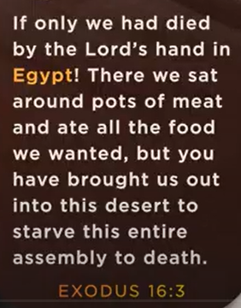

Exodus 16:3

If only we had died by the Lord’s hand in Egypt. There we sat around pots of meats and at all the food we wanted, but you have brought us out into this desert to starve this entire assembly to death.

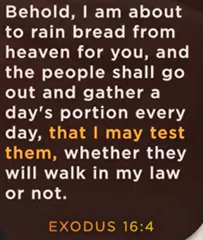

Exodus 16:4

I am about to rain bread from heaven for you.

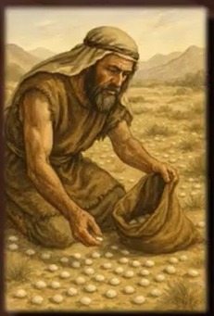

Israelites is in Egypt for 450 for slavery. God want to bring them out of Egypt.



Daily provision and feel like delayed provision.

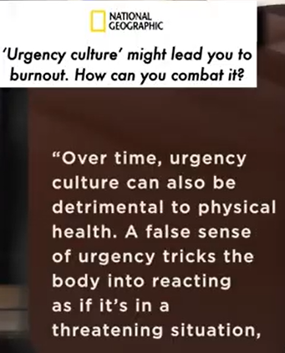 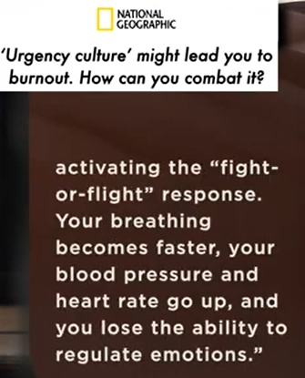

What is the problem of Isarael?

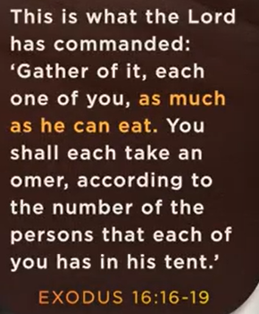 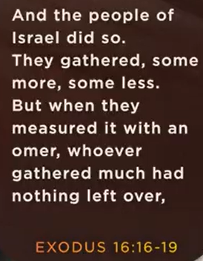 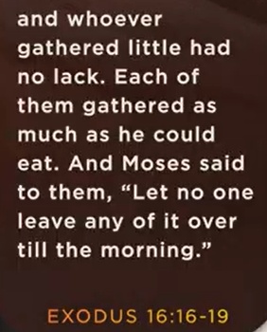

Exodus 16:16-19

God slowly form a different vision for future.

In the morning, each person takes 2 quart of bread. Carry with bread and move out of Egypt.



Rest requires readiness. Need to work and ready before rest.

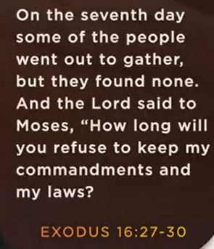 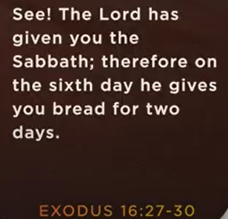

Exodus 16:27-30

God give us the Sabbath. The 7th day give us bread for one-day rest.

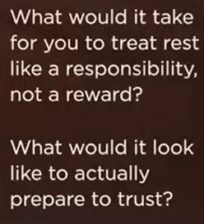

Take rest like a responsibility, not a reward.

I trust God to show up if he does not show up. I am still good in Sabbath day.

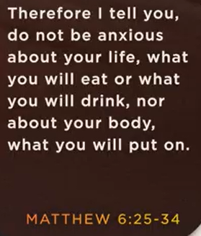 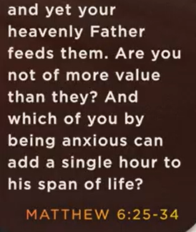 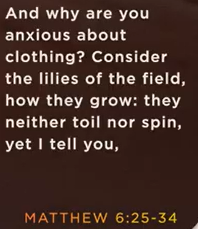

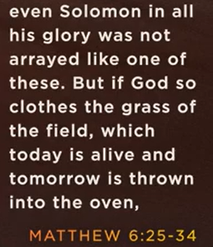 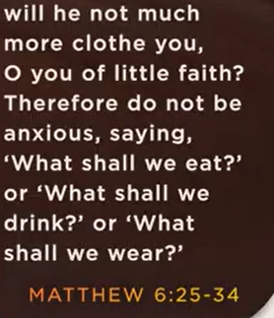 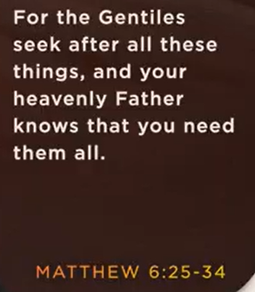

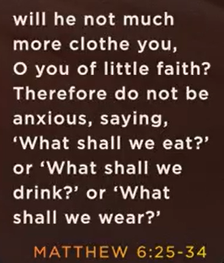 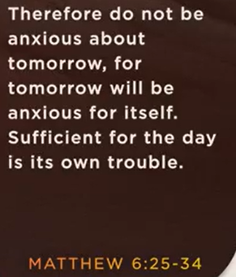

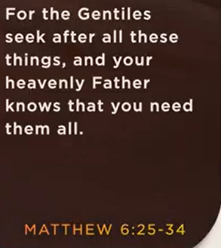 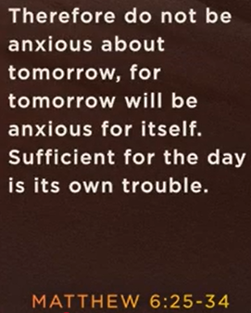

Matthew 6:35-34

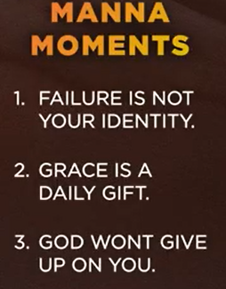

What is “manna Moment”?

"Manna moment" refers to an unexpected and significant blessing, aid, or provision, often likened to the miraculous food (manna) provided to the Israelites in the Bible. It signifies a time when one receives help or good fortune that feels divinely ordained or incredibly timely. The term is also used to describe a moment of spiritual enlightenment or revelation.

Manna Moment:

1. Failure is not your identity

2. Graces is daily gift

3. God won’t give up on you.

08/15/2025, Legacy (last week) Worship

<https://www.youtube.com/live/JIH8CL6Zbg0?si=ADVseIQl9nHbKCom>

“It’s Never Too Late to Turn Back / Foreign Faith,” Phil EuBank, Lead Pastor

Summary:

In the wilderness, Israel grumbled, rebelled, and doubted. God provided manna, unexpected food from God. Failure isn't fatal until the final.

1. In Exodus 16:3, In wilderness, Israelites need food, lose faith, and want food/slavery in Egypt.

2. In Exodus 16:4, God promise manna (provide food) for the Israelites in wilderness.

3. In Exodus 16:16-19, God provides manna (God only give bread from Monday to Saturday).

4. In Exodus 16:27-30, Israelites disobey God and get bread on Sabbath (Sunday).

5. In Matthew 6:33-34, we trust God will provide food and clothes in his kingdom.

6. Manna (God gives food) moment:

a. Failure is not your identity: God’s grace overcomes our failure

b. We receive God's grace as daily gifts.

c. God will never give up on us.